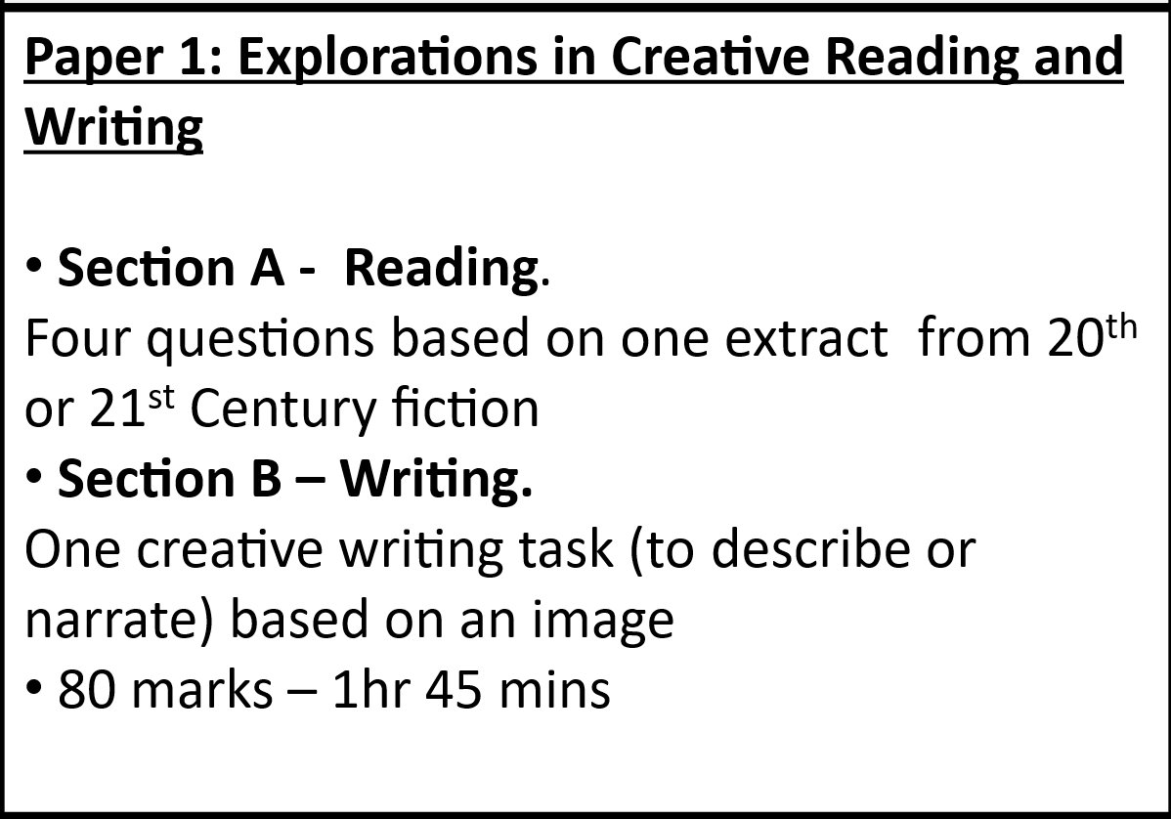
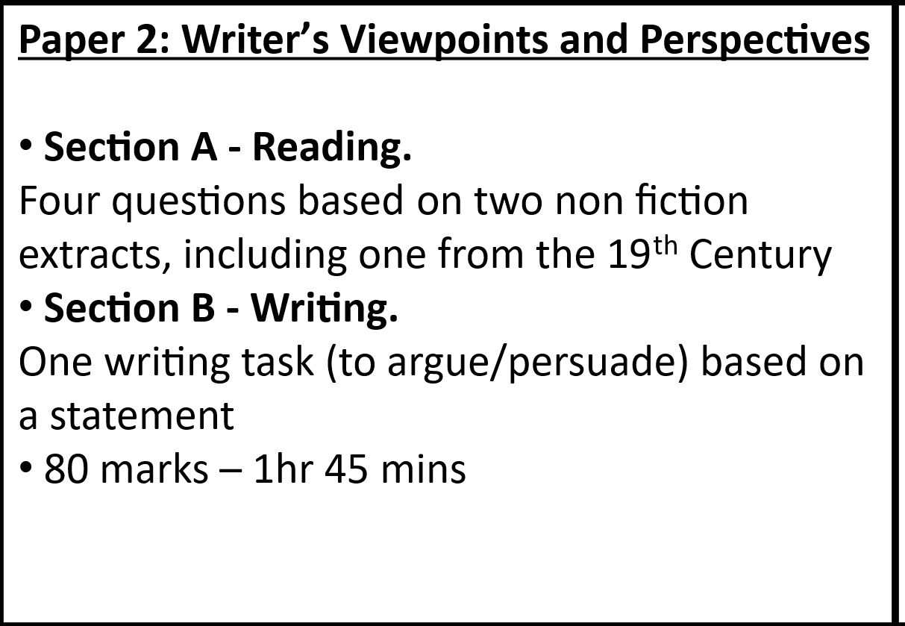
AQA English Language
https://www.bbc.co.uk/bitesize/examspecs/zcbchv4

https://www.thenational.academy/teachers/programmes/english-secondary-ks4-aqa/units?category=language&learning-theme=all

Language Paper 1: Explorations in Creative Reading and Writing
Question | What You Do | Marks | Skill Tested
Q1 | List 4 things from the text | 4 | Retrieval
Q2 | Analyse how language is used | 8 | Language analysis
Q3 | Analyse how structure is used | 8 | Structure analysis
Q4 | Evaluate a statement about the text | 20 | Critical evaluation
Q5 | Writing to describe or narrate | 40 | Creative Writing

Focus: Fiction
Worth: 50% of GCSE
Sections: A (Reading) & B (Writing)

English Language Paper 2: Writers’ Viewpoints and Perspectives
Question | What You Do | Marks | Skill Tested
Q1 | Pick 4 true statements | 4 | Retrieval
Q2 | Summarise differences between texts | 8 | Comparison of ideas
Q3 | Analyse language in one text | 12 | Language analysis
Q4 | Compare viewpoints & perspectives | 16 | Comparison + evaluation
Q5 | Transactional Writing | 40 | Writing for a purpose
Assessment Objectives
AO1: Retrieval information (Find it), AO2: Analyse Methods (How it’s done), AO3: Compare texts (Link texts), AO4: Evaluate (Give your opinion), AO5: Writing content (Ideas and structure), AO6: Writing accuracy (SPaG)
Focus: Non-fiction
Worth: 50% of GCSE
Sections: A (Reading) & B (Writing)

