GCSE English at The Forest Academy

Exam Specification | Board: AQA  English Language Paper 1 (Explorations in Creative Reading and Writing - 1 hour 45 minutes)  - Section A Reading – AO1/AO2/AO4 (4 questions – Q1-multiple choice, Q2-language analysis, Q3-structure analysis, Q4-evaluation)  - Section B Writing – AO5/AO6 (1 question – descriptive or narrative)  English Language Paper 2 (Writer’s Viewpoints and Perspectives - 1 hour 45 minutes)  - Section A Reading AO1/AO2/AO3 (4 questions – Q1- shade 4 true statements, Q2-infer similarities or difference, Q3-language analysis, Q4-compare writers’ perspectives and feelings)  - Section B Writing – AO5/AO6 (1 question – writing an article or letter or speech on a controversial topic)  English Literature Paper 1 (Shakespeare and the 19th Century Novel – 1 hour 45 minutes)  - Section A Macbeth  - Section B A Christmas Carol  English Literature Paper 2 (Modern Texts and Poetry – 1 hour 45 minutes)  - Section A An Inspector Calls  - Section B Love and Relationships Poetry  - Section C Unseen Poetry  AQA Spoken Endorsement (Speaking and Listening Exam completed in Year 10)
Revision Guides for Language | 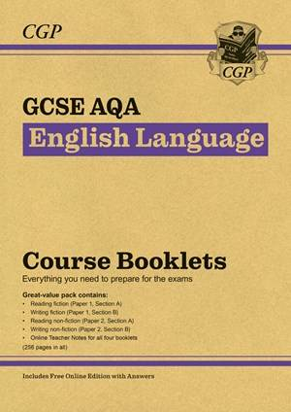  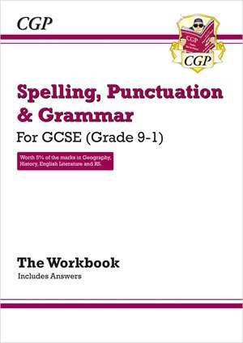
Revision Guides for Literature | 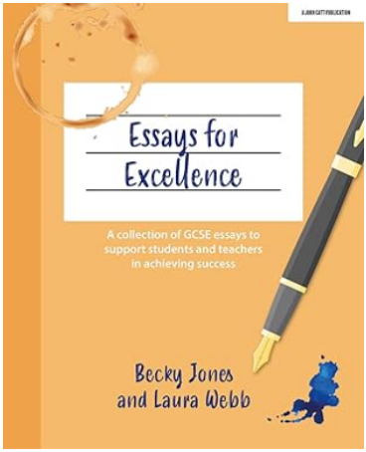  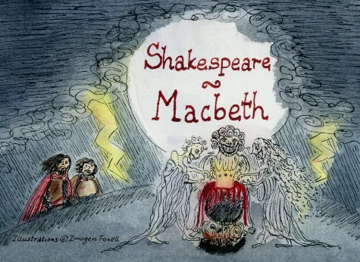  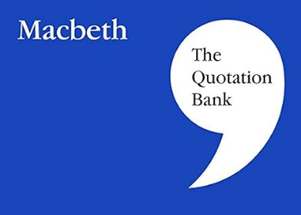  ‘Essays for Excellence’ is an excellent literature revision book because it provides high-quality model essays that show students exactly what top-level responses look like. It helps students understand how to structure essays, develop thoughtful interpretations, and analyse language effectively, making it easier to apply these skills in exams.  ‘A Quotation Bank’ is a great revision resource because it gathers key quotations for each text in one place, organised by theme and character. This helps students revise efficiently, remember evidence more easily, and confidently select relevant quotations to support their ideas in exams.  Flipsco Cards are an effective revision tool because they break down key themes, characters, quotations, and exam questions into clear, manageable sections. Their concise explanations and exam-focused prompts help students revise actively and recall information quickly under exam conditions.
Past Papers and Mark Schemes | Note: AQA are making some changes to the English Language GCSE exam papers. These changes are designed to improve the clarity and accessibility of the papers, but the core skills being assessed remain exactly the same. These changes are to take effect from Summer 2026 onwards.  Below are links for updated Language/Literature Papers:  https://www.aqa.org.uk/subjects/english/gcse/english-8700/assessment-resources (Language and Literature)  https://www.douglaswise.co.uk/blog/reworked-gcse-english-language-papers (reworked Language papers)
Online Revision | Everything Mr English – A well-known experienced English teacher who runs the YouTube channel Everything Mr English. He provides clear, exam-focused support for GCSE students, with videos on essay structure, language and literature analysis, and exam technique. His content includes example answers, question walkthroughs, and practical revision advice to help students prepare effectively and approach English exams with confidence.  https://www.youtube.com/c/MrEverythingEnglish  Mr Bruff – A highly respected English teacher who runs the popular YouTube channel Mr Bruff. He supports GCSE students by clearly explaining English Language and Literature, helping them understand key texts, themes, and exam techniques. His videos include model answers, text analysis, and practical guidance on what examiners are looking for, along with effective revision strategies to build confidence and independence.  https://www.youtube.com/@mrbruff  Physics and Maths Tutor  https://www.physicsandmathstutor.com/english-revision/gcse-aqa/

