Y13- Christmas Holiday Homework
Task:
Using your Key Topic 1 (KT1) notes and additional research, organise all information into thematic timelines. Do not just state key events- there must be a summary of each event. These timelines should help you plan and evaluate essay answers. You will have 5 Timelines- these have been printed for you on A3 paper. You may want to type up your cards- print them and stick them on to your timeline. You have access to this on MS Teams if you would like to download and type up your notes too.
The themes you will be focussing on are:
- Role/attitudes of Presidents & Laws and Legislations
- Supreme Court (Judiciary)
- African American Actions (Groups & Key protest events/actions)
- African American leaders
- Opposition/White attitudes (Violence, Riots, Groups, key individuals e.g. Bull Conor)
- Within timeline you also need to place them on the Y Axis to assess show significant it was.
- Within your timeline you also need to colour code which one shows:
- Social impact/change
- Economic impact/change
- Political impact/change
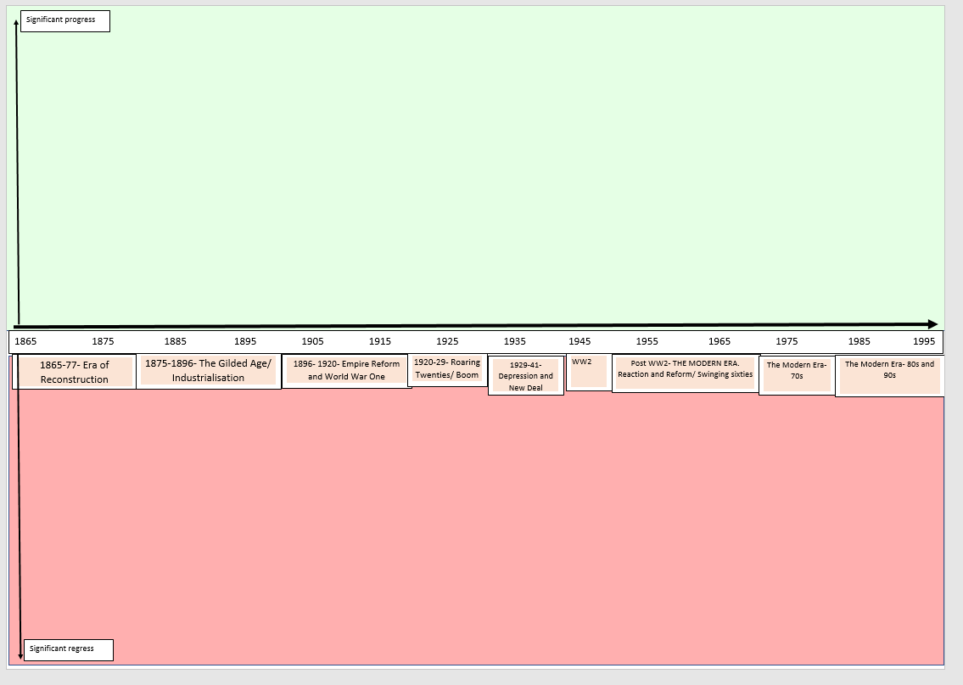
- (some can be two so show 2 colours) So your timeline should look something like this:
Economic
Political
Social
This will be due first lesson back.
You will be judged on the level of effort for each timeline. If it is obvious you have not spent enough time with this revision exercise, sanctions will follow.
ALL 5 timelines WILL NEED TO BE COMPLETE.

