GCSE Combined Science Summer Transition Work Year 10 to year 11
Name: _______________________
Form: _______________________

Task 1 – Biology Retrieval (B3, B4 & B5)
Part A – The Nervous System
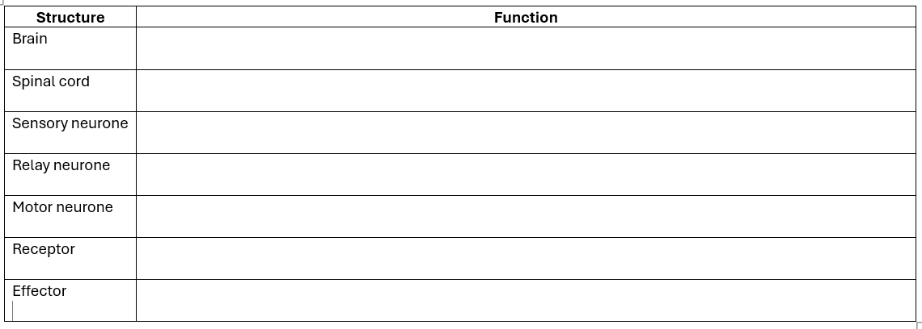
1. Complete the table.
2. Reflexes
Explain:
a) What is a reflex action?
………………………………………………………………………………………….....................................................................................................................................................................
b) Why are reflexes important?
………………………………………………………………………………………….....................................................................................................................................................................
c) Describe the pathway of a reflex arc.
…………………………………………………………………………………………....................................................................................................................................................................
3. The Eye
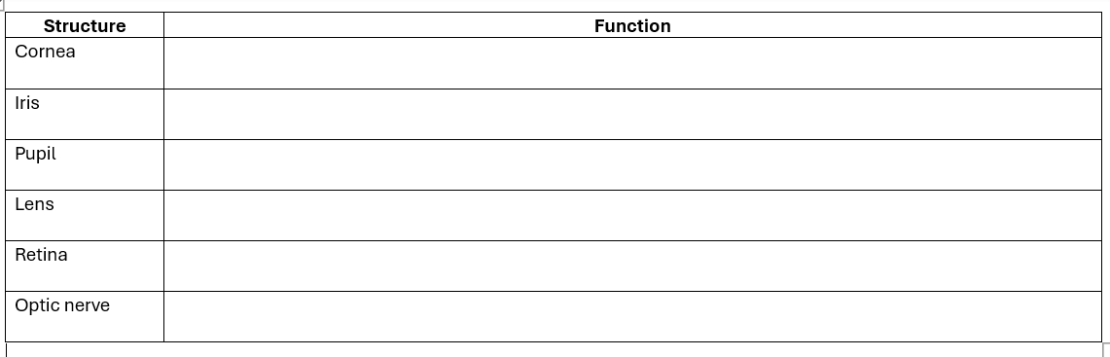
Complete the table.
4. Required Practical
Describe how you would investigate reaction time.
Include:
- Independent variable
- Dependent variable
- Control variables
- Method
- Safety

…………………………………………………………………………………………........................................................................................................................................................................................................................................................................................................…………………………………………………………………………………………........................................................................................................................................................................................................................................................................................................…………………………………………………………………………………………........................................................................................................................................................................................................................................................................................................…………………………………………………………………………………………........................................................................................................................................................................................................................................................................................................
…………………………………………………………………………………………........................................................................................................................................................................................................................................................................................................…………………………………………………………………………………………........................................................................................................................................................................................................................................................................................................…………………………………………………………………………………………........................................................................................................................................................................................................................................................................................................…………………………………………………………………………………………........................................................................................................................................................................................................................................................................................................
Part B – Hormones and Negative Feedback
1. Complete the table.
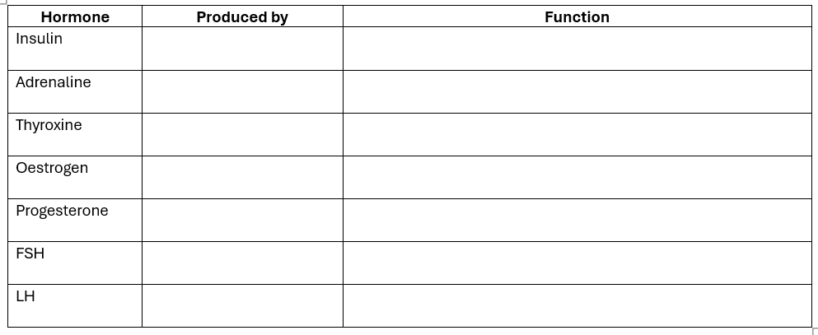
2. Explain what is meant by negative feedback.
………………………………………………………………………………………….....................................................................................................................................................................………………………………………………………………………………………….....................................................................................................................................................................

3. Diabetes
Compare Type 1 and Type 2 diabetes.
………………………………………………………………………………………….....................................................................................................................................................................………………………………………………………………………………………….....................................................................................................................................................................
Part C – The Menstrual Cycle
Describe the role of:
- FSH ………………………………………………………………………………………………………………………………………………………………………………………………………………………………
- LH ………………………………………………………………………………………………………………………………………………………………………………………………………………………………
- Oestrogen ………………………………………………………………………………………………………………………………………………………………………………………………………………………………
- Progesterone ………………………………………………………………………………………………………………………………………………………………………………………………………………………………

Explain how the contraceptive pill prevents pregnancy.
………………………………………………………………………………………….....................................................................................................................................................................
………………………………………………………………………………………….....................................................................................................................................................................

Part D – Ecosystems (B4)
1. Define:
- Ecosystem ………………………………………………………………………………………………………………………………………………………………………………………………………………………………
- Habitat ………………………………………………………………………………………………………………………………………………………………………………………………………………………………
- Community ………………………………………………………………………………………………………………………………………………………………………………………………………………………………
- Population ………………………………………………………………………………………………………………………………………………………………………………………………………………………………
- Biodiversity ………………………………………………………………………………………………………………………………………………………………………………………………………………………………

2. Food Chains
Construct a food chain using:
Grass
Rabbit
Fox
Identify:
- Producer
- Primary consumer
- Secondary consumer
………………………………………………………………………………………………………………………………………………………………………………………………………………………………………………
………………………………………………………………………………………………………………………………………………………………………………………………………………………………………………
………………………………………………………………………………………………………………………………………………………………………………………………………………………………………………
………………………………………………………………………………………………………………………………………………………………………………………………………………………………………………
3. Explain why biodiversity is important.
………………………………………………………………………………………………………………………………………………………………………………………………………………………………………………
………………………………………………………………………………………………………………………………………………………………………………………………………………………………………………
………………………………………………………………………………………………………………………………………………………………………………………………………………………………………………
………………………………………………………………………………………………………………………………………………………………………………………………………………………………………………
4. Required Practical
Describe how you would estimate plant population using a quadrat.
………………………………………………………………………………………………………………………………………………………………………………………………………………………………………………………………………………………………………………………………………………………………………………………………………………………………………………………………………………………………………………………………………………………………………………………………………………………………………………………………………………………………………………………………………………
………………………………………………………………………………………………………………………………………………………………………………………………………………………………………………
Part E – Variation and Evolution (B5)
1. Complete the table.
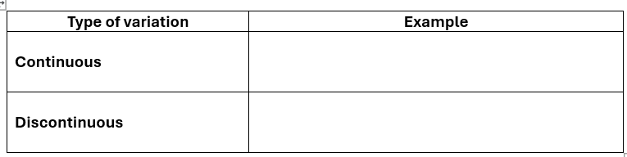
2. Explain the difference between inherited and environmental variation.
………………………………………………………………………………………………………………………………………………………………………………………………………………………………………………………………………………………………………………………………………………………………………………………………………………………………………………………………………………………………
3. Natural Selection
Describe how natural selection leads to evolution.
………………………………………………………………………………………………………………………………………………………………………………………………………………………………………………………………………………………………………………………………………………………………………………………………………………………………………………………………………………………………

4. Genetic Crosses
Complete the Punnett squares.
Brown eyes (B) dominant over blue (b)

Bb × Bb

Cystic fibrosis (f) recessive
Ff × Ff
Calculate:
- Genotype ratio
- Phenotype ratio
- Probability of an affected child

Challenge Questions
- Explain why reflexes are faster than voluntary responses.
………………………………………………………………………………………………………………………………………………………………………………………………………………………………
- Explain how negative feedback maintains stable blood glucose concentration.
………………………………………………………………………………………………………………………………………………………………………………………………………………………………
- Explain why genetic variation is essential for natural selection.
………………………………………………………………………………………………………………………………………………………………………………………………………………………………

- Explain how reducing biodiversity affects ecosystems.
………………………………………………………………………………………………………………………………………………………………………………………………………………………………
………………………………………………………………………………………………………………………………………………………………………………………………………………………………
- Explain why dominant alleles do not always become more common.
………………………………………………………………………………………………………………………………………………………………………………………………………………………………
………………………………………………………………………………………………………………………………………………………………………………………………………………………………

Task 2 – Chemistry Retrieval (C3, C4 & C5)
Part A – Chemical Equations
1. Balance the following equations.
….. Mg + ……. O₂ → ……MgO
…….H₂ +……. Cl₂ → ……. HCl
……. Fe + ……. O₂ → ……. Fe₂O₃
……. CH₄ + ……. O₂ → ……. CO₂ + ……. H₂O

2. Explain why chemical equations must be balanced.
……………………………………………………………………………………………………………………………………………………………………………………………………………………………………………………………………………………………………………………………………………………………………………………………………………………………………………………………………………………………….
Part B – Half Equations
Write half equations for:
- Oxidation of magnesium ………………………………………………………………………………………………………………………………………………………………………………………………………………………………
- Reduction of copper ions ………………………………………………………………………………………………………………………………………………………………………………………………………………………………
- Formation of chlorine gas ………………………………………………………………………………………………………………………………………………………………………………………………………………………………

Explain the difference between oxidation and reduction.
………………………………………………………………………………………………………………………………………………………………………………………………………………………………………………
………………………………………………………………………………………………………………………………………………………………………………………………………………………………………………
Part C – Mole Calculations
1. Define the mole.
………………………………………………………………………………………………………………………………………………………………………………………………………………………………………………
………………………………………………………………………………………………………………………………………………………………………………………………………………………………………………

2. Calculate the number of moles in:
- 36 g H₂O
…………………………………………………………………………………………………………………………………………………………………………………………………………………………………………
- 44 g CO₂
…………………………………………………………………………………………………………………………………………………………………………………………………………………………………………
- 117 g NaCl
…………………………………………………………………………………………………………………………………………………………………………………………………………………………………………

3. Calculate the mass of:
0.5 moles of MgO
………………………………………………………………………………………………………………………………………………………………………………………………………………………………………………
………………………………………………………………………………………………………………………………………………………………………………………………………………………………………………

2 moles of CaCO₃
………………………………………………………………………………………………………………………………………………………………………………………………………………………………………………
………………………………………………………………………………………………………………………………………………………………………………………………………………………………………………
Part D – Exothermic and Endothermic Reactions
  - . Complete the table.
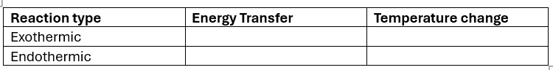

2. Give two examples of each.
………………………………………………………………………………………………………………………………………………………………………………………………………………………………………………
………………………………………………………………………………………………………………………………………………………………………………………………………………………………………………

3. Explain why combustion is exothermic.
………………………………………………………………………………………………………………………………………………………………………………………………………………………………………………………………………………………………………………………………………………………………………………………………………………………………………………………………………………………………

4. Explain why thermal decomposition is endothermic.
………………………………………………………………………………………………………………………………………………………………………………………………………………………………………………………………………………………………………………………………………………………………………………………………………………………………………………………………………………………………
Part E – Electrolysis
1. Define:
- Electrolysis ………………………………………………………………………………………………………………………………………………………………………………………………………………………………
- Electrolyte ………………………………………………………………………………………………………………………………………………………………………………………………………………………………
- Cathode ………………………………………………………………………………………………………………………………………………………………………………………………………………………………
- Anode ………………………………………………………………………………………………………………………………………………………………………………………………………………………………

2. State the products formed during electrolysis of:
- Molten lead bromide
……………………………………………………………………………………………………………………………………………………………………………………………………………………………………………………………………………………………..……………………………………………………………………………………………………………………………………………………………………………………

- Concentrated sodium chloride solution
………………………………………………………………………………………………………………………………………………………………………………………………………………………………………………………………………………………………………………………………………………………………………………………………………………………………………………………………………………………………
3. Explain why ions move towards opposite electrodes.
………………………………………………………………………………………………………………………………………………………………………………………………………………………………………………………………………………………………………………………………………………………………………………………………………………………………………………………………………………………………

Part F – Group 1, Group 7 and Group 0
Group 1
Explain the trends in:
- Reactivity
………………………………………………………………………………………………………………………………………………………………………………………………………………………………………………
Melting point
…………………………………………………………………………………………………………………………………………………………………………………………………………………………………………

Group 7
Explain the trends in:
- Reactivity
………………………………………………………………………………………………………………………………………………………………………………………………………………………………………………

- Melting point
………………………………………………………………………………………………………………………………………………………………………………………………………………………………………………..
Describe displacement reactions.
………………………………………………………………………………………………………………………………………………………………………………………………………………………………………………

Group 0
Explain why noble gases are unreactive.
………………………………………………………………………………………………………………………………………………………………………………………………………………………………………………………………………………………………………………………………………………………………………………………………………………………………………………………………………………………………
State one use for:
- Helium
…………………………………………………………………………………………………………………………………………………………………………………………………………………………………………
- Argon
…………………………………………………………………………………………………………………………………………………………………………………………………………………………………………
- Neon
…………………………………………………………………………………………………………………………………………………………………………………………………………………………………………
Part G – Rates of Reaction
1. State five factors that affect the rate of reaction.
………………………………………………………………………………………………………………………………………………………………………………………………………………………………………………………………………………………………………………………………………………………………………………………………………………………………………………………………………………………………………………………………………………………………………………………………………………………………………………………………………………………………………………………………………………………………………………………………………………………………………………………………………………………………………………………………………………………………………………………………
………………………………………………………………………………………………………………………………………………………………………………………………………………………………………………
2. Explain how collision theory explains reaction rates.
………………………………………………………………………………………………………………………………………………………………………………………………………………………………………………………………………………………………………………………………………………………………………………………………………………………………………………………………………………………………………………………………………………………………………………………………………………………………………………………………………………………………………………………………………………………………………………………………………………………………………………………………………………………………………………………………………………………………………………………………………………………………………………………………………………………………………………………………………………………………………………………………………………………………………………
3. Explain how catalysts work.
………………………………………………………………………………………………………………………………………………………………………………………………………………………………………………………………………………………………………………………………………………………………………………………………………………………………………………………………………………………………
4. Required Practical
Describe how you would investigate the effect of concentration on reaction rate.
………………………………………………………………………………………………………………………………………………………………………………………………………………………………………………………………………………………………………………………………………………………………………………………………………………………………………………………………………………………………………………………………………………………………………………………………………………………………………………………………………………………………………………………………………………………………………………………………………………………………………………………………………………………………………………………………………………………………………………………………

Part H – Equilibrium
1. Define dynamic equilibrium.
………………………………………………………………………………………………………………………………………………………………………………………………………………………………………………
2. Explain why equilibrium can only occur in a closed system.
………………………………………………………………………………………………………………………………………………………………………………………………………………………………………………
3. Describe how changing:
- Temperature
- Pressure
- Concentration
affects equilibrium.
………………………………………………………………………………………………………………………………………………………………………………………………………………………………………………………………………………………………………………………………………………………………………………………………………………………………………………………………………………………………………………………………………………………………………………………………………………………………………………………………………………………………………………………………………………………………………………………………………………………………………………………………………………………………………………………………………………………………………………………………………………………………………………………………………………………………………………………………………………………………………………………………………………………………………………
4. Explain Le Chatelier's Principle.
………………………………………………………………………………………………………………………………………………………………………………………………………………………………………………………………………………………………………………………………………………………………………………………………………………………………………………………………………………………………
Challenge Questions
- Explain why increasing temperature increases reaction rate using collision theory.
………………………………………………………………………………………………………………………………………………………………………………………………………………………………
………………………………………………………………………………………………………………………………………………………………………………………………………………………………
- Explain why catalysts do not change the position of equilibrium.
………………………………………………………………………………………………………………………………………………………………………………………………………………………………
………………………………………………………………………………………………………………………………………………………………………………………………………………………………
- Explain why electrolysis requires ionic substances.
………………………………………………………………………………………………………………………………………………………………………………………………………………………………
………………………………………………………………………………………………………………………………………………………………………………………………………………………………
- Explain why Group 1 metals become more reactive down the group.
………………………………………………………………………………………………………………………………………………………………………………………………………………………………
………………………………………………………………………………………………………………………………………………………………………………………………………………………………
- A student reacts 4 g of magnesium with excess oxygen. Calculate the maximum mass of magnesium oxide produced.
………………………………………………………………………………………………………………………………………………………………………………………………………………………………
………………………………………………………………………………………………………………………………………………………………………………………………………………………………
Task 3 – Physics Retrieval (P3, P4 & P5)
Part A – Static Electricity (P3)
1. Define:
- Static electricity
……………………………………………………………………………………………………………………
- Electric charge
……………………………………………………………………………………………………………………
- Insulator
……………………………………………………………………………………………………………………
- Conductor
……………………………………………………………………………………………………………………
- Earthing
……………………………………………………………………………………………………………………
2. Explain:
a) How an object becomes positively charged.
…………………………………………………………………………………………………………………..
……………………………………………………………………………………………………………………
b) How an object becomes negatively charged.
……………………………………………………………………………………………………………………
……………………………………………………………………………………………………………………
c) Why static electricity builds up on insulators.
……………………………………………………………………………………………………………………
……………………………………………………………………………………………………………………

3. Describe two everyday examples of static electricity.
……………………………………………………………………………………………………………………
……………………………………………………………………………………………………………………
4. Explain why lightning is an example of static electricity.
……………………………………………………………………………………………………………………
……………………………………………………………………………………………………………………
Part B – Electric Circuits
1. Complete the table.
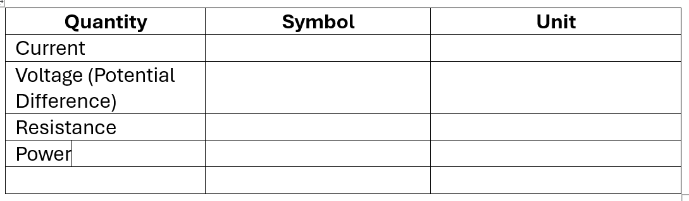
2. State the difference between:
- Series circuits
- Parallel circuits
……………………………………………………………………………………………………………………………………………………………………………………………………………………………………………………………………………………………………………………………………………………………………………………………………………………………………………………………………………………………….

3. Describe what happens to:
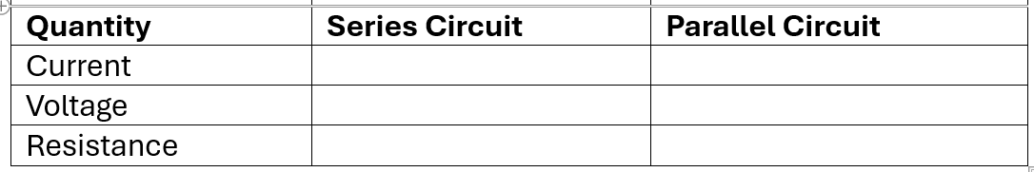
4. Draw circuit symbols for:
- Cell ……………………………………………………………………………………………………..
- Battery ………………………………………………………………………………………………….
- Lamp ……………………………………………………………………………………………………
- Resistor ………………………………………………………………………………………………..
- Variable resistor …………………………………………………………………………………….
- Ammeter ………………………………………………………………………………………………..
- Voltmeter ……………………………………………………………………………………………….
- Switch ……………………………………………………………………………………………………
5. Calculate
A lamp has:
Current = 0.40 A
Resistance = 15 Ω
Calculate the potential difference across the lamp.
…………………………………………………………………………………………………………………………………………………………………………………………………………………………………………
A battery provides 12 V to a resistor of 24 Ω.
Calculate the current.
…………………………………………………………………………………………………………………………………………………………………………………………………………………………………………
6. Required Practical
Describe how you would investigate the relationship between current and potential difference for a resistor.
Include:
- Independent variable
- Dependent variable
- Control variables
- Equipment
- Method
- Safety
………………………………………………………………………………………………………………………………………………………………………………………………………………………………………………………………………………………………………………………………………………………………………………………………………………………………………………………………………………………………………………………………………………………………………………………………………………………………………………………………………………………………………………………………………………………………………………………………………………………………………………………………………………………………………………………………………………………………………………………………………………………………………………………………………………………………………………………………………………………………………………………………………………………………………………………………………………………………………………………………………………………………………………………………………………………………………………………………………………………………………………………………………………………………………………………………………………………………………………………………………………………………………………………………………………………………………………………………………………………………………………………………………………………………………………………………………………………………………………………………………………………………………………………………………………………………………………………………………………………………………………………………………………………………………………
Part C – Magnets and Magnetism
1. Complete the table.
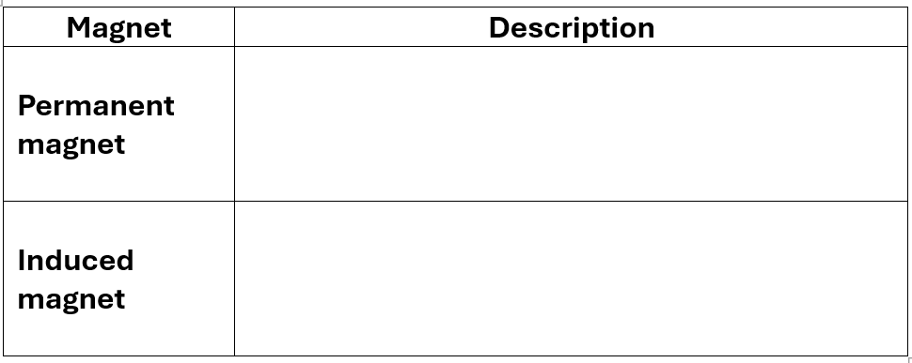
2. Explain:
a) Why unlike poles attract.
…………………………………………………………………………………………………………………………………………………………………………………………………………………………………………
b) Why like poles repel.
…………………………………………………………………………………………………………………………………………………………………………………………………………………………………………
3. State three magnetic materials.
……………………………………………………………………………………………………………………………………………………………………………………………………………………………………………………………………………………………………………………………………………………………………………………………………………………………………………………………………………………

4. Describe the magnetic field around:
- A bar magnet
…………………………………………………………………………………………………………………………………………………………………………………………………………………………………………
- A current-carrying wire
…………………………………………………………………………………………………………………………………………………………………………………………………………………………………………
- A solenoid
…………………………………………………………………………………………………………………………………………………………………………………………………………………………………………

5. Explain one use of an electromagnet.
…………………………………………………………………………………………………………………………………………………………………………………………………………………………………………

Part D – Wave Properties (P4)
1. Define:
- Wave
…………………………………………………………………………………………………………………………………………………………………………………………………………………………………………
- Frequency
…………………………………………………………………………………………………………………………………………………………………………………………………………………………………………
- Wavelength
…………………………………………………………………………………………………………………………………………………………………………………………………………………………………………
- Amplitude
…………………………………………………………………………………………………………………………………………………………………………………………………………………………………………
- Period
…………………………………………………………………………………………………………………………………………………………………………………………………………………………………………

2. Complete the table.
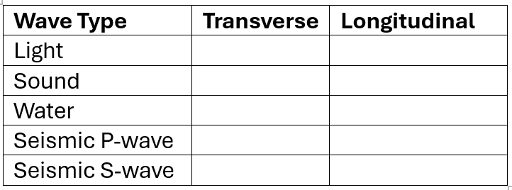
3. Explain the difference between transverse and longitudinal waves.
……………………………………………………………………………………………………………………………………………………………………………………………………………………………………………………………………………………………………………………………………………………………………………………………………………………………………………………………………………………………….
4. A wave has:
Frequency = 8 Hz
Wavelength = 3 m
Calculate the wave speed.
………………………………………………………………………………………………………………………………………………………………………………………………………………………………………………………………………………………………………………………………………………………………………………………………………………………………………………………………………………………………

5. Explain why sound cannot travel through space.
………………………………………………………………………………………………………………………………………………………………………………………………………………………………………………………………………………………………………………………………………………………………………………………………………………………………………………………………………………………………

Part E – Electromagnetic Spectrum
1. Complete the table.
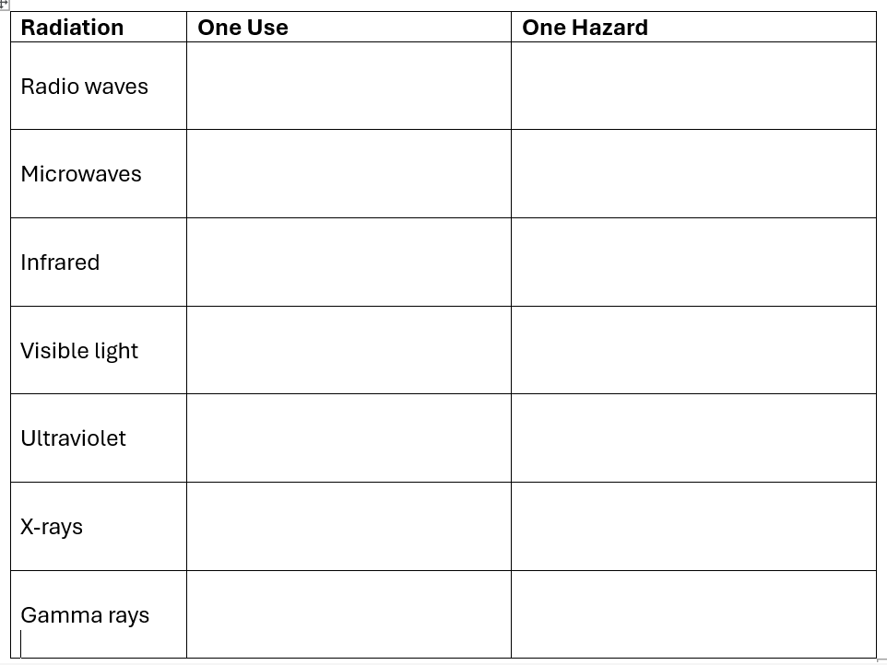
2. Arrange the electromagnetic spectrum from:
- Lowest frequency to highest frequency.
………………………………………………………………………………………………………………………………………………………………………………………………………………………………………………

3. Explain why all electromagnetic waves travel at the same speed in a vacuum.
…………………………………………………………………………………………………………………………………………………………………………………………………………………………………………
Part F – Radioactivity
1. Define:
- Radioactive decay
…………………………………………………………………………………………………………………………………………………………………………………………………………………………………………
- Background radiation
…………………………………………………………………………………………………………………………………………………………………………………………………………………………………………
- Half-life
…………………………………………………………………………………………………………………………………………………………………………………………………………………………………………
- Contamination
…………………………………………………………………………………………………………………………………………………………………………………………………………………………………………
- Irradiation
…………………………………………………………………………………………………………………………………………………………………………………………………………………………………………

2. Complete the table.
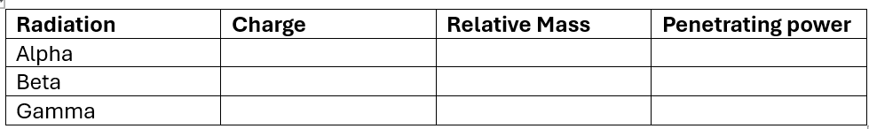
3. Explain:
a) Why alpha particles are stopped by paper.
…………………………………………………………………………………………………………………………………………………………………………………………………………………………………………
b) Why gamma rays require thick lead shielding.
…………………………………………………………………………………………………………………………………………………………………………………………………………………………………………
4. State one medical use of radioactive isotopes.
…………………………………………………………………………………………………………………………………………………………………………………………………………………………………………
5. State one industrial use of radioactive sources.
…………………………………………………………………………………………………………………………………………………………………………………………………………………………………………
Part G – Required Practical Skills
A student investigates how the distance from a light source affects the light intensity measured by a sensor.
Answer the following.
- Independent variable
- Dependent variable
- Three control variables
- Equipment needed
- Safety precautions
- Explain why repeat readings improve reliability.
……………………………………………………………………………………………………………………………………………………………………………………………………………………………………………………………………………………………………………………………………………………………………………………………………………………………………………………………………………………………………………………………………………………………………………………………………………………………………………………………………………………………………………………………………………………………………………………………………………………………………………………………………………………………………………………………………………………………………………………………………………………………………………………………………………………………………………………………………………………………………………………………………………………………………………………………………………………………………………………………………………………………………………………………………………………………………………………………………………………………………………………………………………………………………………………………………………………………………………………………………………………………………………………………………………………………………………………………………………………………………………………………………………………………………………………………………………………………………………………………………………………………………………………………………………………………………………………………………………………………………………………………………………………………………………………………………………………………………………………………………………………………………………………………………………………………………………………………………………………………………………………………………………………………………………………………………………………………………………………………………………………………………………………………………………….

Part H – Mathematical Skills
Complete the following calculations.
Current
A resistor has a resistance of 8 Ω and a current of 2 A.
Calculate the voltage.
…………………………………………………………………………………………………………………………………………………………………………………………………………………………………………
Resistance
A circuit has:
Voltage = 9 V
Current = 0.30 A
Calculate the resistance.
…………………………………………………………………………………………………………………………………………………………………………………………………………………………………………
Wave Speed
Frequency = 250 Hz
Wavelength = 1.4 m
Calculate the wave speed.
…………………………………………………………………………………………………………………………………………………………………………………………………………………………………………
Half-life
A radioactive sample has an initial count rate of 640 counts per minute.
The half-life is 5 hours.
Calculate the count rate after:
a) 5 hours
b) 10 hours
c) 15 hours

……………………………………………………………………………………………………………………………………………………………………………………………………………………………………………………………………………………………………………………………………………………………………………………………………………………………………………………………………………………………………………………………………………………………………………………………………………………………………………………………………………………………………………………………………………….

Challenge Questions
- Explain why birds can safely sit on overhead power lines.
…………………………………………………………………………………………………………………………………………………………………………………………………………………………………………
- Explain why current is the same everywhere in a series circuit but splits in a parallel circuit.
…………………………………………………………………………………………………………………………………………………………………………………………………………………………………………
- Explain why radio waves and gamma rays are both electromagnetic waves despite having very different properties.
…………………………………………………………………………………………………………………………………………………………………………………………………………………………………………
- Describe how an electromagnet can be made stronger.
…………………………………………………………………………………………………………………………………………………………………………………………………………………………………………
- Explain why radioactive isotopes can be both useful and dangerous.
…………………………………………………………………………………………………………………………………………………………………………………………………………………………………………
- A student says, "Gamma radiation is the most dangerous because it has the greatest ionising power." Evaluate this statement.
…………………………………………………………………………………………………………………………………………………………………………………………………………………………………………

