GCSE Combined Science Summer Transition Work Year 9 to Year 10

Name: _______________________
Form: _______________________
Welcome!
You have completed your first year of GCSE Combined Science. During Year 9 you studied:
- B1 – Cell Level Systems
- B2 – Scaling Up
- C1 – Particles
- C2 – Elements, Compounds and Mixtures
- P1 – Matter
- P2 – Forces
This booklet will help you remember the key ideas from these topics so that you are ready for Year 10.
Bring this completed booklet to your first Science lesson in September.
Biology Retrieval
Part A – Cell Biology
1. Cell Structure
Complete the table below.
Cell Structure | Function
Nucleus
Cell membrane
Cytoplasm
Mitochondria
Ribosomes
Chloroplast
Permanent vacuole
Cell wall

2. Cell Types
a) State two differences between plant and animal cells.
...……………………………………………………………………………………………………………………
………………………………………………………………………………………………………………………
………………………………………………………………………………………………………………………
b) State two differences between eukaryotic and prokaryotic cells.
...……………………………………………………………………………………………………………………
………………………………………………………………………………………………………………………
………………………………………………………………………………………………………………………
3. Microscopy
a) Write the equation for magnification.
b) Calculate the magnification if:
Image size = 90 mm
Actual size = 0.3 mm

Part B – Cell Transport
Define:
- Diffusion
...…………………………………………………………………………………………………………………
...…………………………………………………………………………………………………………………
……………………………………………………………………………………………………………………

- Osmosis
...………………………………………………………………………………………………………………………….…………………………………………………………………………………………………………..……………………………………………………………………………………………………………………

- Active Transport
...………………………………………………………………………………………………………………………….…………………………………………………………………………………………………………..……………………………………………………………………………………………………………………
- For each process, give one example from plants or animals.
...………………………………………………………………………………………………………………………….…………………………………………………………………………………………………………..……………………………………………………………………………………………………………………

Part C – Enzymes
1. Complete the table.
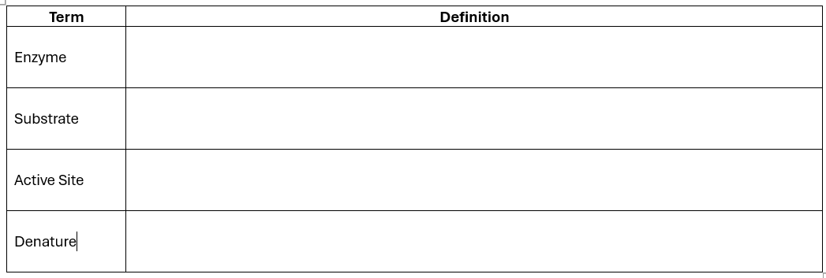
2. Explain:
a) Why enzymes are described as biological catalysts.
………………………………………………………………………………………………………………………..
………………………………………………………………………………………………………………………..
………………………………………………………………………………………………………………………..

b) Why temperature affects enzyme activity.
………………………………………………………………………………………………………………………..
………………………………………………………………………………………………………………………..
………………………………………………………………………………………………………………………..

c) Why pH affects enzyme activity.
………………………………………………………………………………………………………………………..
………………………………………………………………………………………………………………………..
………………………………………………………………………………………………………………………..

3. Required Practical
The graph below shows enzyme activity at different temperatures.
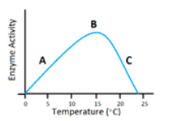

Answer:
- What is the optimum temperature?
………………………………………………………………………………………………………………………………………………………………………………………………………………………………
- Why does the rate decrease above the optimum temperature?
………………………………………………………………………………………………………………………………………………………………………………………………………………………………

- Explain your answer using the active site model.
………………………………………………………………………………………………………………………………………………………………………………………………………………………………

Part D – Photosynthesis
- Write the balanced symbol equation for photosynthesis.
………………………………………………………………………………………………………………
- State:
- the reactants: ………………………………………………………………………………………….
- the products: ………………………………………………………………………………………….
- Why is chlorophyll needed?
………………………………………………………………………………………………………………
- Explain how each of the following affects the rate of photosynthesis:
- Light intensity ………………………………………………………………………………………….
- Carbon dioxide concentration ……………………………………………………………………
- Temperature …………………………………………………………………………………………..
- Explain why farmers sometimes use greenhouses to increase crop yield.
………………………………………………………………………………………………………………………..
………………………………………………………………………………………………………………………..
………………………………………………………………………………………………………………………..
Part E – Respiration
Aerobic
- Write the word equation for aerobic respiration.
………………………………………………………………………………………………………………
- State where respiration takes place in the cell.
………………………………………………………………………………………………………………
- Compare aerobic and anaerobic respiration.
………………………………………………………………………………………………………………
………………………………………………………………………………………………………………
………………………………………………………………………………………………………………
………………………………………………………………………………………………………………
Anaerobic
- Why do muscles produce lactic acid during vigorous exercise?
………………………………………………………………………………………………………………
………………………………………………………………………………………………………………
………………………………………………………………………………………………………………

- Explain why respiration is essential for living organisms.
………………………………………………………………………………………………………………
………………………………………………………………………………………………………………
………………………………………………………………………………………………………………

Part F – Organisation
Complete the sequence.
Cell → __________ → __________ → Organ System → Organism
Give one example for each level.
……………………………………………………………………………………………………………………..
……………………………………………………………………………………………………………………..
……………………………………………………………………………………………………………………..

Part G – Circulatory System
1. Label a diagram of the heart.
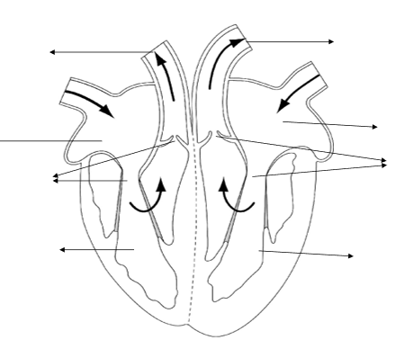
- Left atrium
- Right atrium
- Left ventricle
- Right ventricle
- Aorta
- Vena cava
- Pulmonary artery
- Pulmonary vein

2. Blood Vessels
Complete the table.
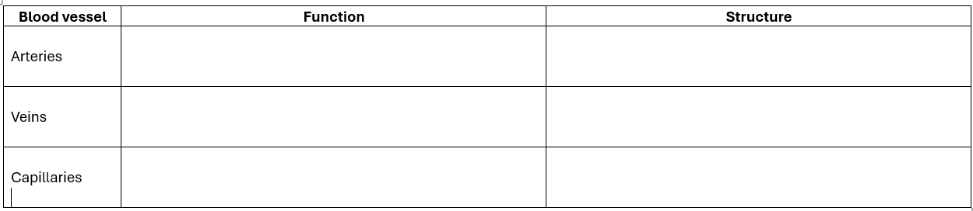

3. Blood
State the function of:
- Red blood cells
………………………………………………………………………………………………………………
- White blood cells
………………………………………………………………………………………………………………
- Platelets
……………………………………………………………………………………………………………..
- Plasma
…………………………………………………………………………………………………………….

4. Lifestyle
Explain how the following increase the risk of cardiovascular disease.
- Smoking
………………………………………………………………………………………………………………
………………………………………………………………………………………………………………
- Poor diet
……………………………………………………………………………………………………………..
…………………………………………………………………………………………………………….
- Lack of exercise
……………………………………………………………………………………………………………..
……………………………………………………………………………………………………………..

Part H – Plant Transport
1. Complete the table.
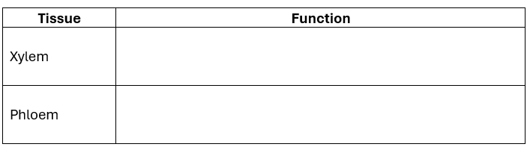
2. Explain:
a) How water moves from the roots to the leaves.
……………………………………………………………………………………………………………………..
b) Why transpiration is important.
……………………………………………………………………………………………………………………..
c) Name three factors that affect transpiration.
……………………………………………………………………………………………………………………..

3. Required Practical
Describe how you could investigate the effect of light intensity on transpiration using a potometer.
Include:
- Independent variable
- Dependent variable
- Control variables
- Safety precautions
……………………………………………………………………………………………………………………….
……………………………………………………………………………………………………………………….
……………………………………………………………………………………………………………………….
……………………………………………………………………………………………………………………….
……………………………………………………………………………………………………………………….
……………………………………………………………………………………………………………………….
……………………………………………………………………………………………………………………….
……………………………………………………………………………………………………………………….
Challenge Questions
- Explain why a large surface area is important in both the lungs and the small intestine.
…………………………………………………………………………………………………………
…………………………………………………………………………………………………………
…………………………………………………………………………………………………………
- Explain why mitochondria are found in large numbers in muscle cells.
…………………………………………………………………………………………………………
…………………………………………………………………………………………………………
…………………………………………………………………………………………………………
- Why does increasing carbon dioxide concentration not always increase the rate of photosynthesis?
………………………………………………………………………………………………………….
…………………………………………………………………………………………………………….
…………………………………………………………………………………………………………….

- Explain why xylem vessels are dead cells but phloem vessels are living cells.
…………………………………………………………………………………………………………….
…………………………………………………………………………………………………………….
…………………………………………………………………………………………………………….
- A marathon runner breathes more rapidly during a race. Explain why.
…………………………………………………………………………………………………………….

…………………………………………………………………………………………………………….

…………………………………………………………………………………………………………….

Task 2 – Chemistry Retrieval (C1 & C2)
Part A – Particle Model
  - States of Matter
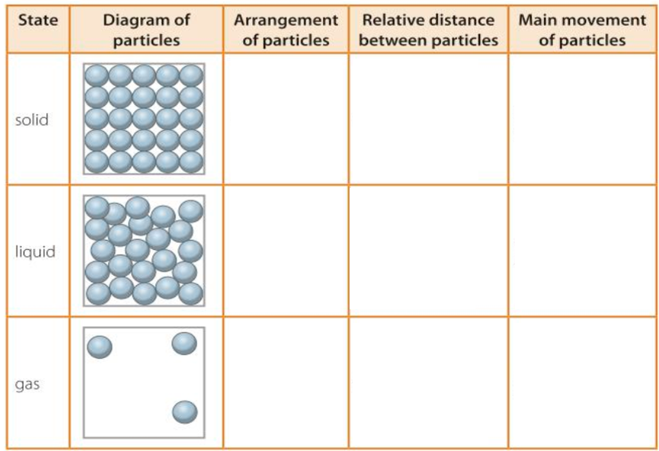
Complete the table

2. Changes of State
Change of State | Name of Process
Solid → Liquid | …………………………………………………………
Liquid → Gas | ………………………………………………………..
Gas → Liquid | ………………………………………………………..
Liquid → Solid | ………………………………………………………..
Solid → Gas | ………………………………………………………..
Gas → Solid | ………………………………………………………..

3. Explain
a) Why gases can be compressed but solids cannot.
……………………………………………………………………………………………………………………..
……………………………………………………………………………………………………………………..
b) Explain why diffusion occurs faster in gases than in liquids.
……………………………………………………………………………………………………………………..
……………………………………………………………………………………………………………………..
c) Describe what happens to the particles when ice melts.
……………………………………………………………………………………………………………………..
……………………………………………………………………………………………………………………..
Part B – Atomic Structure
1. Complete the table.
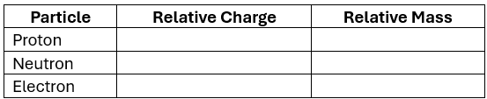
2. Define the following terms.
- Atom ………………………………………………………………………………………………………………
- Element ………………………………………………………………………………………………………………
- Compound ………………………………………………………………………………………………………………
- Mixture ………………………………………………………………………………………………………………
- Molecule ………………………………………………………………………………………………………………

3. Atomic Structure
Complete the following.
- Atomic number = __________________________________________________________
- Mass number = ____________________________________________________________

4. Calculate
An atom has:
- 17 protons
- 18 neutrons
State:
a) Atomic number: ……………………………….
b) Mass number: ……………………………….
c) Number of electrons: ……………………..

Part C – Isotopes
1. Explain what an isotope is.
………………………………………………………………………………………………………………………
………………………………………………………………………………………………………………………
2. Carbon-12 and Carbon-14 are isotopes.
Explain:
a) What they have in common
………………………………………………………………………………………………………………………
………………………………………………………………………………………………………………………
b) What is different.
………………………………………………………………………………………………………………………
………………………………………………………………………………………………………………………

3. Why do isotopes of the same element have similar chemical properties?
………………………………………………………………………………………………………………………
………………………………………………………………………………………………………………………

Part D – Electronic Structure
1. Draw the electron arrangements for:
- Oxygen

- Sodium

- Magnesium

- Chlorine

2. Explain why elements in the same group have similar chemical properties.
………………………………………………………………………………………………………………………..………………………………………………………………………………………………………………………..……………………………………………….……………………………………………………………………….

3. Explain why Group 0 elements are unreactive.
……………………………………………………………………………………………………………………………………………………………………………………………………………………………………………………………………………………………….………………………………………………………………………………………………………………………………………………………………………………………………

Part E – The Periodic Table
1. Explain how the Periodic Table is arranged.
……………………………………………………………………………………………………………………………………………………………………………………………………………………………………………………………………………………………….………………………………………………………………………………………………………………………………………………………………………………………………

2. Define:
- Group ………………………………………………………………………………………………………………………………………………………………………………………………………………………………………………………………………………………
- Period ……………………………………………………………………………………………………………………………………………………………………………………………………………………………………………………………………………………….

3. Name:
- Three metals ………………………………………………………………………….
- Three non-metals …………………………………………………………………..

4. Explain two differences between metals and non-metals.
……………………………………………………………………………………………………………………………………………………………………………………………………………………………………………………………………………………………….………………………………………………………………………………………………………………………………………………………………………………………………

Part F – Bonding
1. Complete the table.
Bond Type | Between Which Elements? | Electrons are...
Ionic | ……………………………………….
Covalent | ……………………………………….

2. Explain how:
a) Ionic bonding forms.
……………………………………………………………………………………………………………………………………………………………………………………………………………………………………………………………………………………………….………………………………………………………………………………………………………………………………………………………………………………………………

b) Covalent bonding forms.
……………………………………………………………………………………………………………………………………………………………………………………………………………………………………………………………………………………………….………………………………………………………………………………………………………………………………………………………………………………………………

3. State two properties of ionic compounds.
……………………………………………………………………………………………………………………………………………………………………………………………………………………………………………………………………………………………….………………………………………………………………………………………………………………………………………………………………………………………………

4. State two properties of simple covalent substances.
……………………………………………………………………………………………………………………………………………………………………………………………………………………………………………………………………………………………….………………………………………………………………………………………………………………………………………………………………………………………………

Part G – Carbon Chemistry
Diamond
Explain why diamond:
- is extremely hard.
………………………………………………………………………………………………………………………..………………………………………………………………………………………………………………………..……………………………………………….……………………………………………………………………….………………………………………………………………………………………………………………………..
- has a very high melting point.
………………………………………………………………………………………………………………………..………………………………………………………………………………………………………………………..……………………………………………….……………………………………………………………………….………………………………………………………………………………………………………………………..

- does not conduct electricity.
………………………………………………………………………………………………………………………..………………………………………………………………………………………………………………………..……………………………………………….……………………………………………………………………….………………………………………………………………………………………………………………………..

Graphite
Explain why graphite:
- conducts electricity.
………………………………………………………………………………………………………………………..………………………………………………………………………………………………………………………..……………………………………………….……………………………………………………………………….………………………………………………………………………………………………………………………..
- is soft and slippery.
………………………………………………………………………………………………………………………..………………………………………………………………………………………………………………………..……………………………………………….……………………………………………………………………….………………………………………………………………………………………………………………………..

- has a high melting point.
………………………………………………………………………………………………………………………..……………………………………………………………………………………………………………….………..……………………………………………….……………………………………………………………………….……………………………………………………………………………………………………..

Compare
Complete the table.
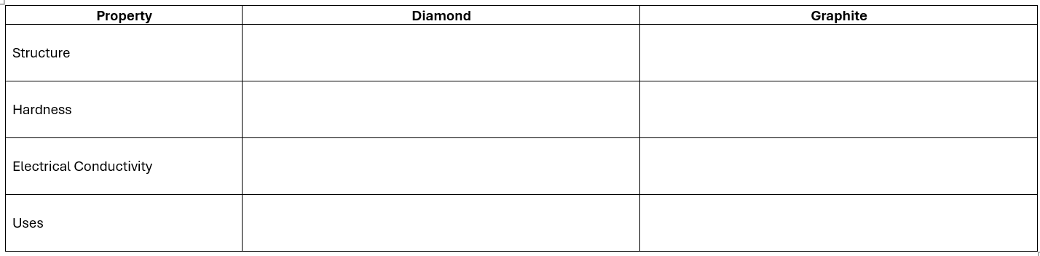
Part H – Relative Formula Mass (Mr)
1. Define:
Relative Formula Mass (Mr)
………………………………………………………………………………………………………………………..………………………………………………………………………………………………………………………..
2. Calculate the Mr of:
a) H₂O
………………………………………………………………………………………………………………………..………………………………………………………………………………………………………………………..
b) CO₂
………………………………………………………………………………………………………………………..………………………………………………………………………………………………………………………..
c) CH₄
………………………………………………………………………………………………………………………………………………………………………………………………………………………………………………

d) NaCl
………………………………………………………………………………………………………………………………………………………………………………………………………………………………………………
e) CaCO₃
………………………………………………………………………………………………………………………………………………………………………………………………………………………………………………
(Use the Periodic Table to find the relative atomic masses.)

Part I – Separation Techniques
1. Complete the table.
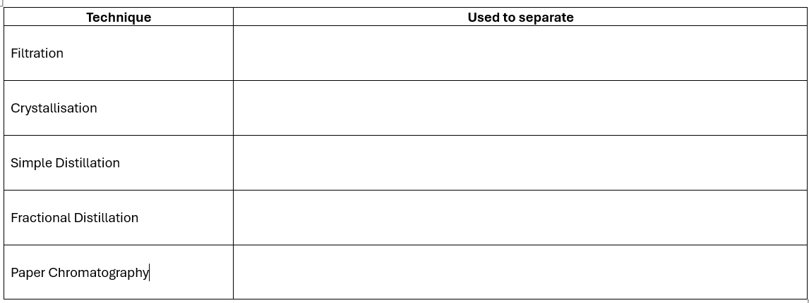
2. Explain:
a) Why filtration cannot separate dissolved salt from water.
………………………………………………………………………………………………………………………………………………………………………………………………………………………………………………….………………………………………………………..…………………………………………………………………………………………………………………………………………………………………………………
b) How crystallisation produces pure crystals.
……………………………………………………………………………………………………………………….……………………………………………………………………………………………………………………….………………………………………………………..……………………………………………………………………………………………………………………………………………………………………………………….

c) Why chromatography is useful in forensic science.
………………………………………………………………………………………………………………………………………………………………………………………………………………………………………………………………………………………………………..………………………………………………………………………………………………………………………………………………………………………………………
3. Required Practical
A student wants to separate sand and salt from a mixture.
Describe the method they should use.
Include:
- Equipment required
- Method
- Why each stage is necessary
………………………………………………………………………………………………………………………..………………………………………………………………………………………………………………………..……………………………………………….……………………………………………………………………….………………………………………………………………………………………………………………………..
………………………………………………………………………………………………………………………..………………………………………………………………………………………………………………………..……………………………………………….……………………………………………………………………….……………………………………………………………………………………………………………………….………………………………………………………………………………………………………………………..………………………………………………………………………………………………………………………..……………………………………………….……………………………………………………………………….………………………………………………………………………………………………………………………..………………………………………………………………………………………………………………………..………………………………………………………………………………………………………………………..……………………………………………….……………………………………………………………………….………………………………………………………………………………………………………………………..………………………………………………………………………………………………………………………..………………………………………………………………………………………………………………………..……………………………………………….……………………………………………………………………….………………………………………………………………………………………………………………………..………………………………………………………………………………………………………………………..………………………………………………………………………………………………………………………..……………………………………………….……………………………………………………………………….……………………………………………………………………………………………………………………….
Challenge Questions
- Explain why ionic compounds conduct electricity when molten but not when solid.
……………………………………………………………………………………………………………………….……………………………………………………………………………………………………………………….………………………………………………………………………………………………………………………..……………………………………………………………………………………………………………………….……………………………………………………………………………………………………………………….

- Why does graphite conduct electricity but diamond does not, even though they are both made only of carbon?
……………………………………………………………………………………………………………………….……………………………………………………………………………………………………………………….………………………………………………………………………………………………………………………..……………………………………………………………………………………………………………………….……………………………………………………………………………………………………………………….

- Explain why isotopes have different masses but nearly identical chemical behaviour.
……………………………………………………………………………………………………………………….……………………………………………………………………………………………………………………….………………………………………………………………………………………………………………………..……………………………………………………………………………………………………………………….……………………………………………………………………………………………………………………….

- A compound has the formula MgCl₂. Explain how magnesium and chlorine form this compound using electron transfer.
……………………………………………………………………………………………………………………….……………………………………………………………………………………………………………………….………………………………………………………………………………………………………………………..……………………………………………………………………………………………………………………….……………………………………………………………………………………………………………………….

- Explain why fractional distillation can separate crude oil into useful fractions.
……………………………………………………………………………………………………………………….……………………………………………………………………………………………………………………….………………………………………………………………………………………………………………………..……………………………………………………………………………………………………………………….………………………………………………………………………………………………

Physics Retrieval (P1 & P2)
Part A – States of Matter
1. Complete the table.
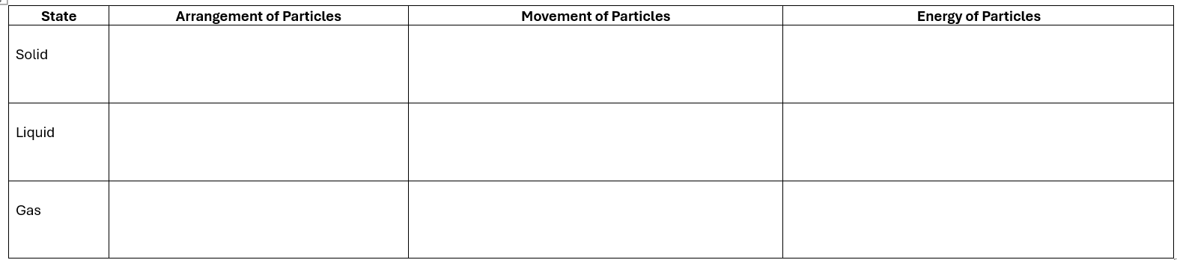
2. Explain:
a) Why heating a substance increases its internal energy.
………………………………………………………………………………………………………………………………………………………………………………………………………………………………………………………………………………………………………………………………………………………………………
b) The difference between temperature and internal energy.
………………………………………………………………………………………………………………………………………………………………………………………………………………………………………………………………………………………………………………………………………………………………………
c) Why gases can be compressed but solids cannot.
………………………………………………………………………………………………………………………………………………………………………………………………………………………………………………………………………………………………………………………………………………………………………

3. Changes of State
Complete the table.
Change | Name
Solid → Liquid
Liquid → Gas
Gas → Liquid
Liquid → Solid

Part B – Specific Heat Capacity
1. Define:
Specific Heat Capacity
………………………………………………………………………………………………………………………………………………………………………………………………………………………………………………………………………………………………………………………………………………………………………
2. Explain why different materials heat up at different rates.
………………………………………………………………………………………………………………………………………………………………………………………………………………………………………………………………………………………………………………………………………………………………………
3. Calculate
a) 2 kg block of aluminium is heated.
Its temperature increases by 15°C.
The specific heat capacity of aluminium is 900 J/kg°C.
Calculate the energy transferred.
………………………………………………………………………………………………………………………………………………………………………………………………………………………………………………………………………………………………………………………………………………………………………

b) A kettle transfers 84 000 J of energy to 2 kg of water.
The specific heat capacity of water is 4200 J/kg°C.
Calculate the temperature increase.
………………………………………………………………………………………………………………………………………………………………………………………………………………………………………………………………………………………………………………………………………………………………………
Part C – Density
1. Define density.
………………………………………………………………………………………………………………………………………………………………………………………………………………………………………………………………………………………………………………………………………………………………………
2. Calculate
Mass = 360 g
Volume = 45 cm³
Calculate the density.
………………………………………………………………………………………………………………………………………………………………………………………………………………………………………………………………………………………………………………………………………………………………………

A material has a density of 2.5 g/cm³.
A sample has a volume of 20 cm³.
Calculate its mass.
………………………………………………………………………………………………………………………………………………………………………………………………………………………………………………………………………………………………………………………………………………………………………
3. Explain why steel sinks but wood usually floats in water.
………………………………………………………………………………………………………………………………………………………………………………………………………………………………………………………………………………………………………………………………………………………………………………………………………………………………………………………………………………………………
Part D – Forces
1. Define:
- Contact force
………………………………………………………………………………………………………………………………………………………………………………………………………………………………………………………………………………………………………………………………………………………………………
- Non-contact force.
………………………………………………………………………………………………………………………………………………………………………………………………………………………………………………………………………………………………………………………………………………………………………

- Resultant force
………………………………………………………………………………………………………………………………………………………………………………………………………………………………………………………………………………………………………………………………………………………………………

2. Give three examples of:
Contact Forces

Non-contact Forces

3. Resultant Force
Two students push a trolley.
Student A pushes with 45 N to the right.
Student B pushes with 20 N to the left.
Calculate:
a) The resultant force.
……………………………………………………………………………………………………………………….……………………………………………………………………………………………………………………….………………………………………………………..……………………………………………………………………………………………………………………………………………………………………………………….
b) The direction of the resultant force.
……………………………………………………………………………………………………………………….……………………………………………………………………………………………………………………….………………………………………………………..……………………………………………………………………………………………………………………………………………………………………………………….
Part E – Newton's Laws
1. Newton's First Law
Explain Newton's First Law using an example from everyday life.
……………………………………………………………………………………………………………………….……………………………………………………………………………………………………………………….………………………………………………………..……………………………………………………………………………………………………………………………………………………………………………………….
2. Newton's Second Law
State the equation linking:
- Force
- Mass
- Acceleration
……………………………………………………………………………………………………………………….……………………………………………………………………………………………………………………….………………………………………………………..……………………………………………………………………………………………………………………………………………………………………………………….

A car of mass 900 kg accelerates at 3 m/s².
Calculate the resultant force.
……………………………………………………………………………………………………………………….……………………………………………………………………………………………………………………….………………………………………………………..……………………………………………………………………………………………………………………………………………………………………………………….

3. Newton's Third Law
Explain Newton's Third Law.
Give two everyday examples.
……………………………………………………………………………………………………………………….……………………………………………………………………………………………………………………….………………………………………………………..……………………………………………………………………………………………………………………………………………………………………………………….

Part F – Hooke's Law
1. Define:
Elastic deformation
……………………………………………………………………………………………………………………….……………………………………………………………………………………………………………………….………………………………………………………..……………………………………………………………………………………………………………………………………………………………………………………….

Plastic deformation
……………………………………………………………………………………………………………………….……………………………………………………………………………………………………………………….………………………………………………………..……………………………………………………………………………………………………………………………………………………………………………………….

Limit of proportionality
……………………………………………………………………………………………………………………….……………………………………………………………………………………………………………………….………………………………………………………..……………………………………………………………………………………………………………………………………………………………………………………….

2. State Hooke's Law.
……………………………………………………………………………………………………………………….……………………………………………………………………………………………………………………….………………………………………………………..……………………………………………………………………………………………………………………………………………………………………………………….
3. Calculate
A spring has a spring constant of 250 N/m.
It is stretched by 0.12 m.
Calculate the force applied.
……………………………………………………………………………………………………………………….……………………………………………………………………………………………………………………….………………………………………………………..……………………………………………………………………………………………………………………………………………………………………………………….
4. Explain why a spring no longer returns to its original length if stretched beyond its elastic limit.
……………………………………………………………………………………………………………………….……………………………………………………………………………………………………………………….………………………………………………………..……………………………………………………………………………………………………………………………………………………………………………………….

Part G – Distance–Time Graphs
A student walks to school.
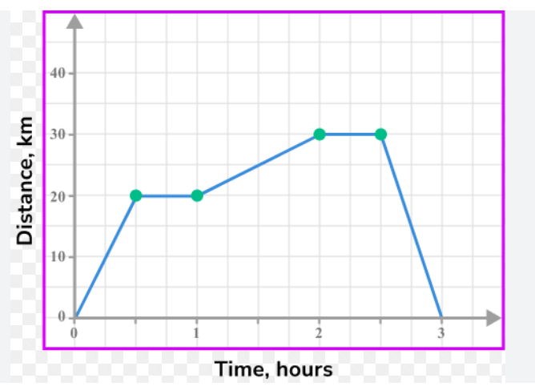
Answer:
- During which section was the student stationary?
………………………………………………………………………………………………………………………………………………………………………………………………………………………………………………………………………………………………………………………………………………
………………………………………………………………………………………………………………………………………………………………………………………………………………………………
- During which section was the student moving fastest?
………………………………………………………………………………………………………………………………………………………………………………………………………………………………………………………………………………………………………………………………………………
………………………………………………………………………………………………………………………………………………………………………………………………………………………………
- Calculate the speed for one section of the graph.
………………………………………………………………………………………………………………………………………………………………………………………………………………………………………………………………………………………………………………………………………………
………………………………………………………………………………………………………………………………………………………………………………………………………………………………

- Explain how you can tell when speed is constant.
………………………………………………………………………………………………………………………………………………………………………………………………………………………………………………………………………………………………………………………………………………
………………………………………………………………………………………………………………………………………………………………………………………………………………………………
Draw
Sketch a distance–time graph for:
- Someone walking at a constant speed.

- Someone standing still.

- Someone walking faster than before.

Part H – Velocity–Time Graphs
A cyclist accelerates, travels at constant velocity and then brakes to a stop.
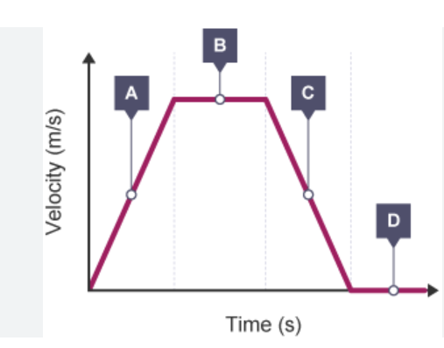
Answer:
- Which section shows acceleration?
………………………………………………………………………………………………………………………………………………………………………………………………………………………………………………………………………………………………………………………………………………………………
- Which section shows constant velocity?
………………………………………………………………………………………………………………………………………………………………………………………………………………………………………………………………………………………………………………………………………………………………
- Which section shows deceleration?
………………………………………………………………………………………………………………………………………………………………………………………………………………………………………………………………………………………………………………………………………………………………
- Calculate the acceleration for one section.
………………………………………………………………………………………………………………………………………………………………………………………………………………………………………………………………………………………………………………………………………………………………
- Explain what the area under the graph represents.
………………………………………………………………………………………………………………………………………………………………………………………………………………………………………………………………………………………………………………………………………………………………

Part I – Investigating Forces
A student investigates how the force applied to a spring affects its extension.
Answer:
- Independent variable
- Dependent variable
- Three control variables
- Equipment required
- Safety precautions
- Why should measurements be repeated?

………………………………………………………………………………………………………………………………………………………………………………………………………………………………………………………………………………………………………..………………………………………………………………………………………………………………………………………………………………………………………………………………………………………………………………………………………………………..………………………………………………………………………………………………………………………………………………………………………………………………………………………………………………………………………………………………………..………………………………………………………………………………………………………………………………………………………………………………………………………………………………………………………………………………………………………..………………………………………………………………………………………………………………………………………………………………………………………………………………………………………………………………………………………………………..………………………………………………………………………………………………………………………………………………………………………………………………………………………………………………………………………………………………………………………………………………………………………………………………………………………………………………………………………………………………………………………………………………………………………………………………………………………………………………………………………………………………………………………………………………………………………………………………………………………………………………………………………………………………………………………………………………………………………………………………………………………………………………………………………………………………………………………………………………………………………………………………………………………………………………………………………………………………………………………………
Challenge Questions
- Explain why seatbelts reduce injuries during a collision using Newton's First Law.
………………………………………………………………………………………………………………………………………………………………………………………………………………………………………………………………………………………………………………………………………………………………

- A heavier object and a lighter object are pushed with the same force. Explain why they accelerate differently.
………………………………………………………………………………………………………………………………………………………………………………………………………………………………………………………………………………………………………………………………………………………………

- Explain why specific heat capacity is important when choosing materials for saucepans.
………………………………………………………………………………………………………………………………………………………………………………………………………………………………………………………………………………………………………………………………………………………………

- Describe how a velocity–time graph can be used to calculate distance travelled.

………………………………………………………………………………………………………………………………………………………………………………………………………………………………………………………………………………………………………………………………………………………………

- Explain why Hooke's Law only applies up to the limit of proportionality.
………………………………………………………………………………………………………………………………………………………………………………………………………………………………………………………………………………………………………………………………………………………………

